**CUSTOMER CARE REGISTRY**

**INTRODUCTION**

**Project Overview:**

After the deployment of a product, it becomes indispensable to get feedback from the customers for the betterment of the product in the long run. We have created a web application to make it easier for the customers/clients to post their grievances/queries/complaints online and have them resolved by an agent as soon as possible.

**Purpose:**

Customers facing problems in the product purchased or service provided is very common. For getting these issues resolved, customers need to physically visit/call the organisation/company which makes it an inconvenient process. Our objective is to create a customised application which allows customers to raise their issue which will be forwarded to admin who assigns agents to rectify the issue. The customer can also keep track of issue to know the current status.

**LITERATURE SURVEY**

**Existing Problem:**

Customers facing problems in the product purchased or service provided is very common. For getting these issues resolved, customers need to physically visit/call the organisation/company which makes it an inconvenient process.

**References:**

[1] https://iopscience.iop.org/article/10.1088/1757 899X/263/4/042073/pdf

[2] https://turcomat.org/index.php/turkbilmat/article/view/ 8766/6835

[3] V. K. Kandhari and K. D. Mohinani, "GPS based complaint redressal system," 2014 IEEE Global Humanitarian Technology Conference - South Asia Satellite (GHTC-SAS), 2014, pp. 51-56, doi: 10.1109/GHTC-SAS.2014.6967558.

[4] https://www.academia.edu/download/64659324/IRJET-V7I61248.pd

**Problem Statement Definition:**

If a customer faces any problem with the product they purchased or in the service provided, it should be addressed and rectified properly in order to get a good user experience. To accomplish this, we need an online customer care registry to process and rectify the complaints in a faster manner. The objective is to create a Cloud based Customer Care Registry where the customer can register their complaints with a detailed description, get assigned with an agent to resolve the complaint and able to track the status of the complaint.

**IDEATION & PROPOSED SOLUTION**

**Empathy Map:**

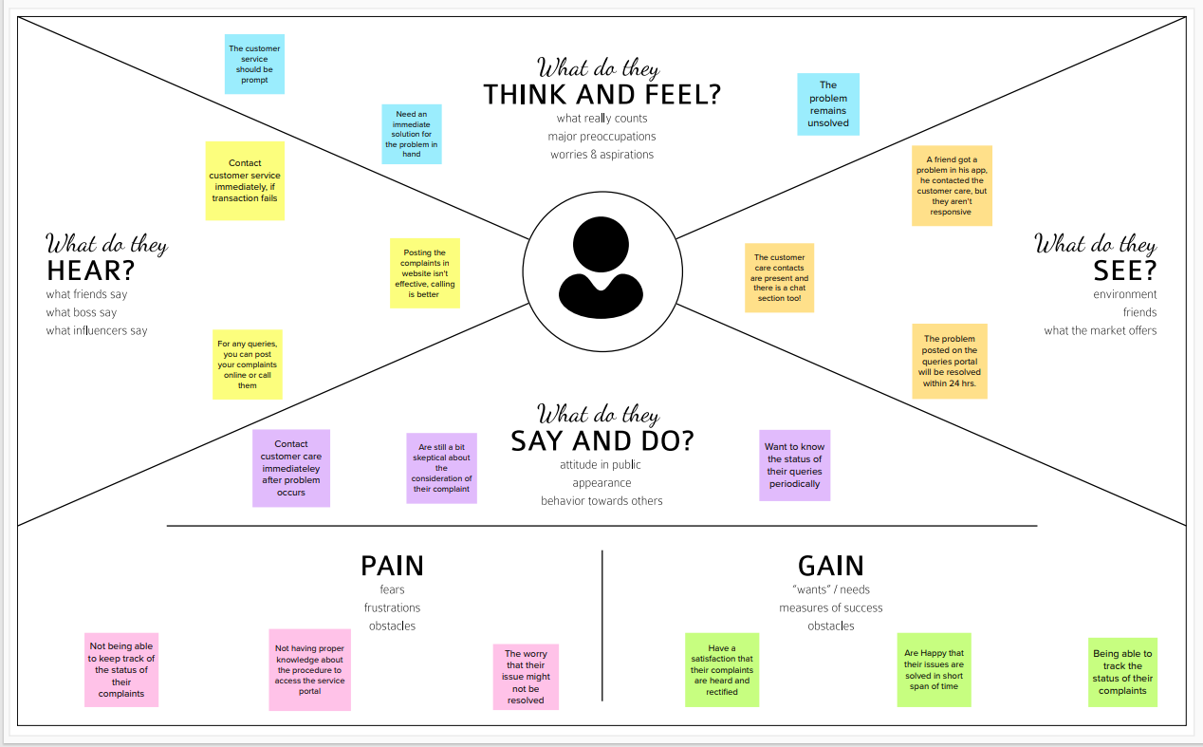

**Ideation and Brainstorming:**

To create a Cloud based Customer Care Registry Web application where the customers can register their complaints with a detailed description, get assigned with an agent to resolve the complaint and are able to track the status of their complaint.

Ideas:

1. Acknowledge customer’s complaint using digital signature.

2. Allowing customer to upload proofs such as images or videos or any relevant documents.

3. Add captcha verification to prevent spam bots that attempt DoS (Denial of Service) attacks

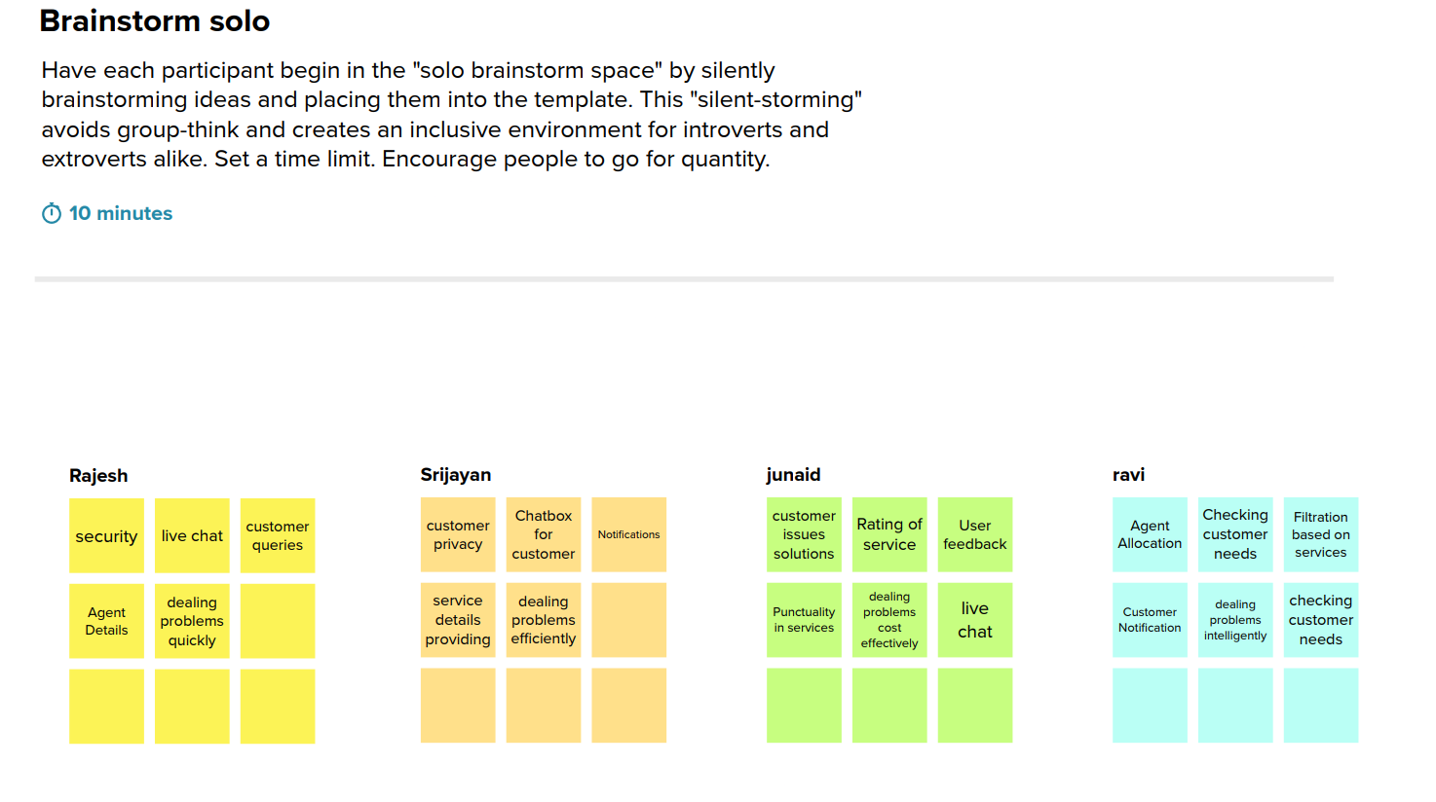

**Proposed solution:**

To create a customised application which allows customers to raise their issue which will be forwarded to admin who assigns agents to rectify the issue and customer can also keep track of issue to know the current status.

**Problem Solution fit:**

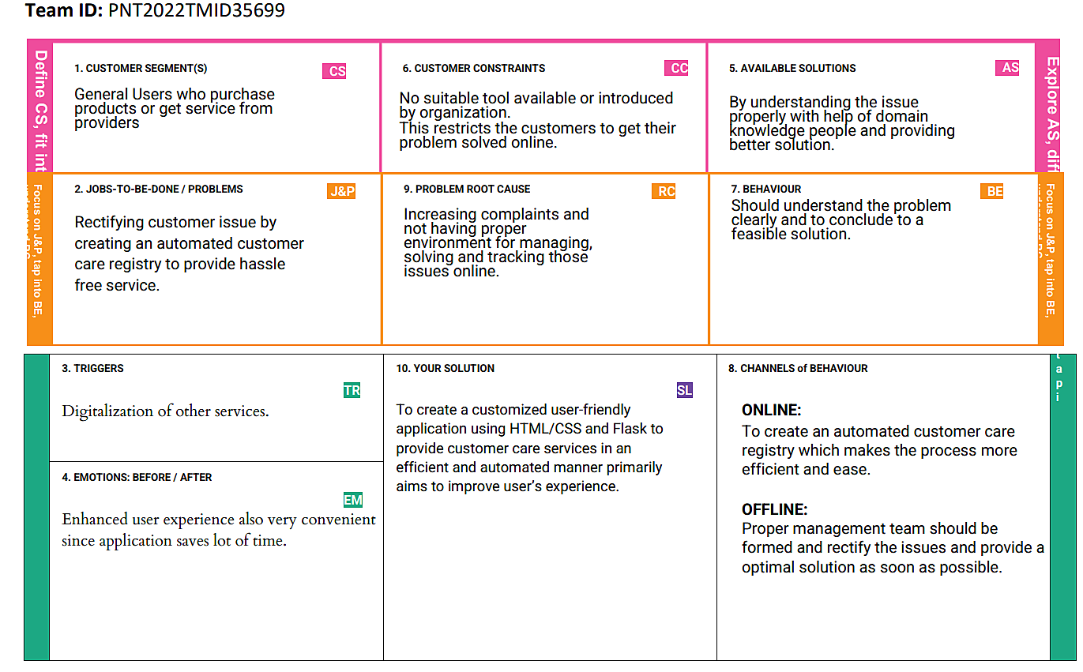

**REQUIREMENT ANALYSIS**

**Functional Requirements:**

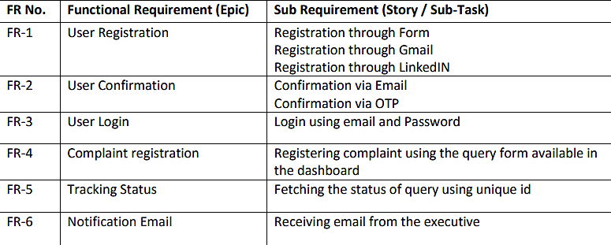

**Non Functional Requirements:**

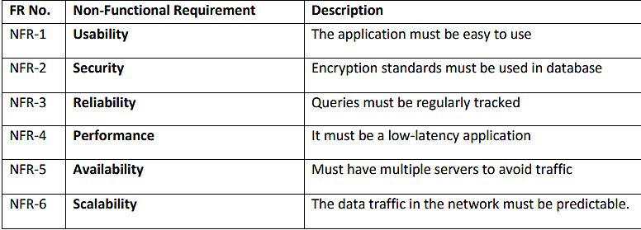

**PROJECT DESIGN**

**Dataflow Diagram:**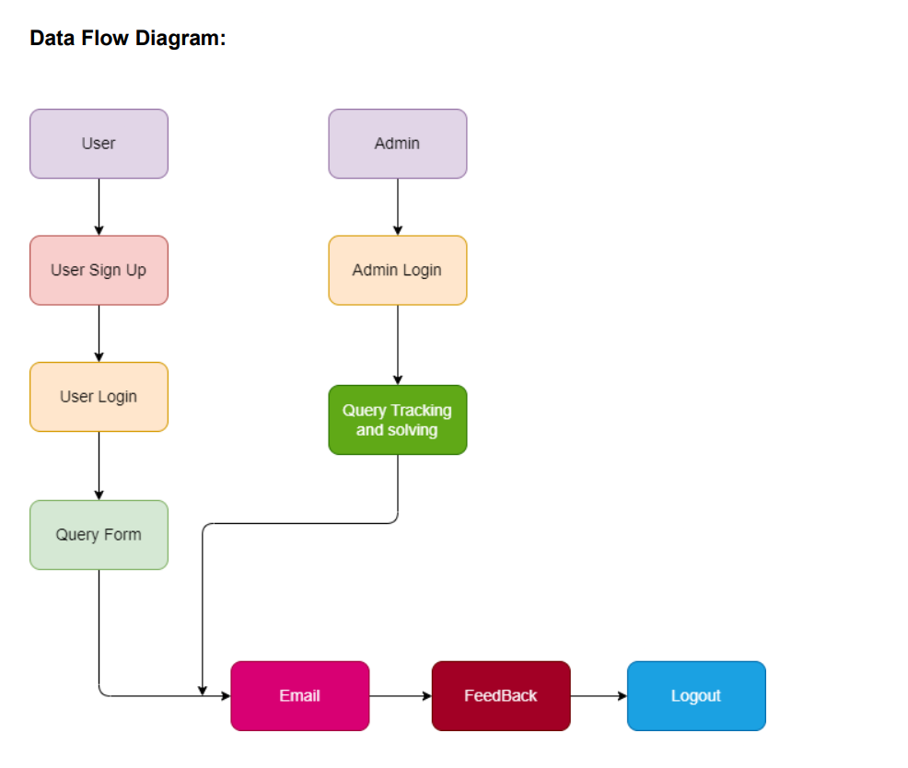

**Solution & Technical Architecture:**

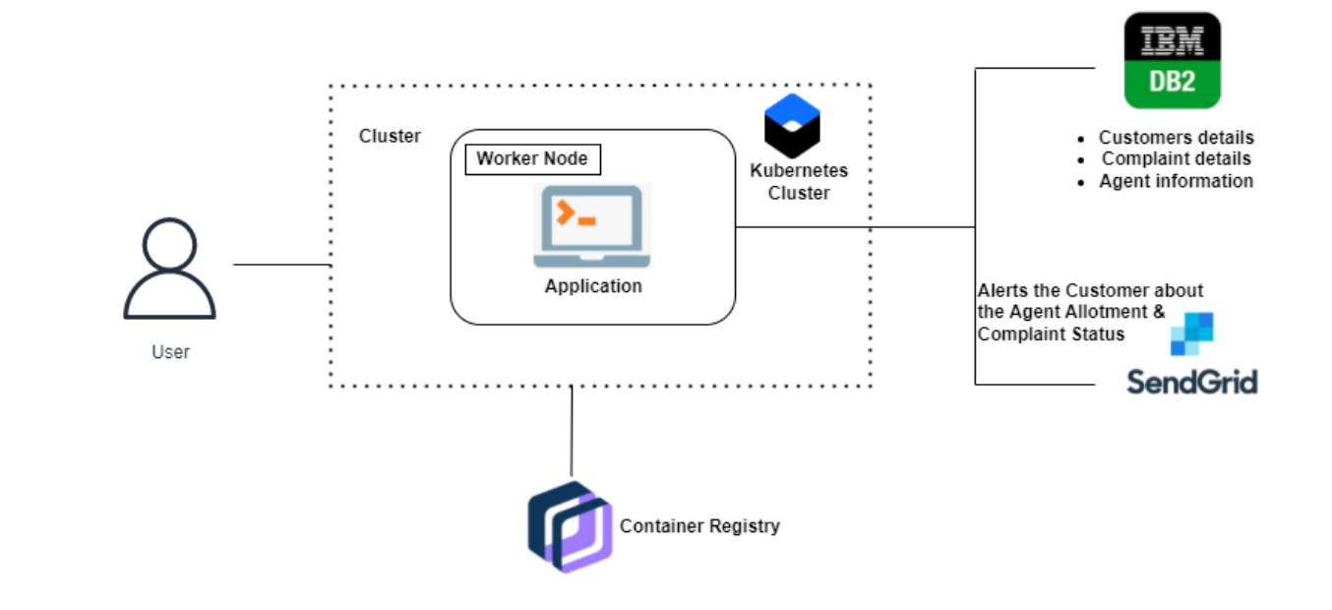

**User Stories:**

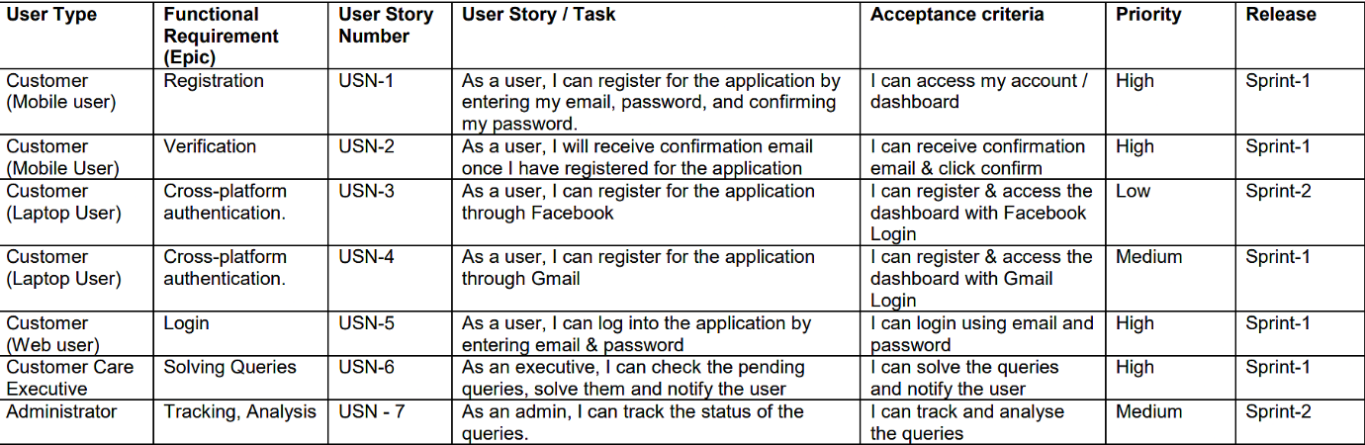

**PROJECT PLANNING & SCHEDULING**

Sprint 1:

* Registration page created
* Loin page created

Sprint 2:

* Database integration done with IBM Db2
* Tables created for storing users’ data
* Validation for user registration/login completed

Sprint 3:

* Created facility for an individual user to post a complaint.
* Created separate table for complaints in Database
* The complaints along with other relevant data (id) will be stored in database.

Sprint 4:

* Facility is provided for admin to assign complaints to staff (agent).
* Separated table is created to map the agent to the complaint assigned for that particular staff.
* The staff can resolve the issue stated and can provide essential feedback to the client.
* The status of the complaint can be tracked by the client.

**Sprint Delivery Schedule:**

Sprint 1 -> 24 - 29 October 2022

Sprint 2 -> 31 October – 5 November 2022

Sprint 3 -> 7 – 12 November 2022

Sprint 4 -> 14 – 19 November 2022

**CODING & SOLUTIONING:**

**Feature 1 (Posting complaints):**

The client can post their complaints in the web application to have them addressed by the staff. The complaint consists of two sections: The ‘subject’ and the ‘content’. The subject has the brief description about the complaint under consideration and the content section has the detailed explanation about the problem. As soon as a complaint is posted, it is sent to the admin for consideration. The admin verifies if it is a valid complaint and assigns it to an agent/staff for resolving.

**Feature 2 (Agent/staff sending feedback to the client):**

In some cases, the staff may require extra information about the situation to resolve the query, or they would also want to notify the client about the time they need to resolve the query. To serve those purposes, we have added a feature wherein the staff can leave a message for the client while attempting to resolve the query, so that the client knows that his complaint has been acknowledged and is being processed.

*The code for the above features is present in our Github repository:*

<https://github.com/IBM-EPBL/IBM-Project-5044-1658746471>

**Database Schemas:**

Schema of ‘users_table’ table:

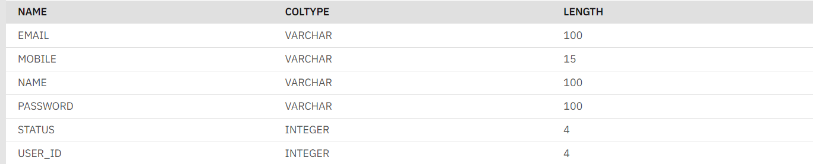

Schema of ‘complaints’ table:

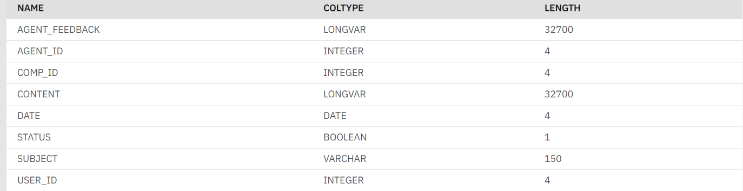

Schema of ‘tasks’ table:

